Q- Program to create STUDENT FORM in Servlet

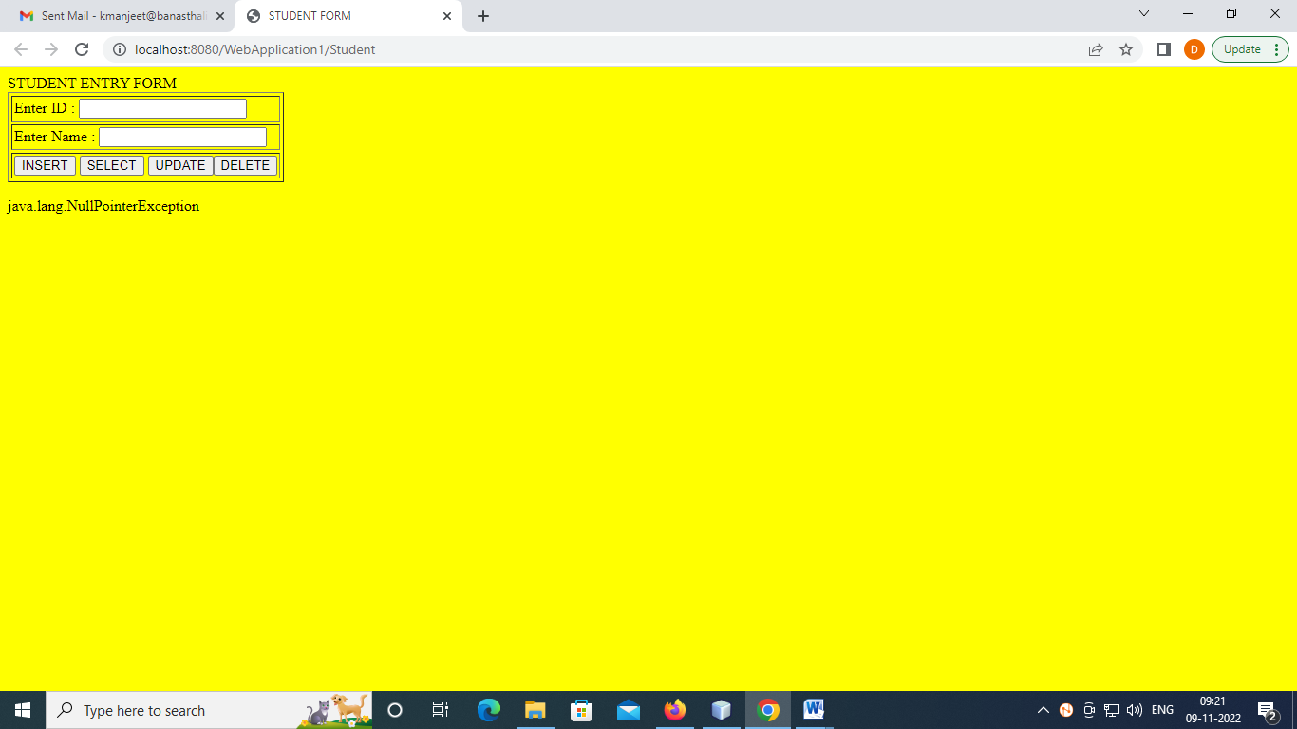

import java.io.*;
import javax.servlet.*;
import javax.servlet.http.*;
import java.sql.*;

public class Student extends HttpServlet {

protected void doGet(HttpServletRequest request, HttpServletResponse response)
throws ServletException, IOException {
response.setContentType("text/html;charset=UTF-8");
PrintWriter out = response.getWriter();

try
{
Class.forName("com.mysql.jdbc.Driver");
Connection conn=DriverManager.getConnection("jdbc:mysql://localhost:3306/manjeet","root","");

out.println("<html>");
out.println("<head>");
out.println("<title>STUDENT FORM</title>");
out.println("</head>");
out.println("<body bgcolor=yellow>");
out.println("<form name='f1'>");
out.println("STUDENT ENTRY FORM");
out.println("<table border='1' cellspacing='3' cellpadding='2'>");
out.println("<tr ><td >Enter ID : <input type='text' value='' name='txtrno'/></td></tr> ");
out.println("<tr ><td >Enter ID : <input type='text' value='' name='txtname'/> </td></tr>");
out.println("<tr><td><input type ='submit' value='INSERT' name='btn'/> <input type ='submit' value='SELECT' name='btn'/> <input type ='submit' value='UPDATE' name='btn'/><input type ='submit' value='DELETE' name='btn'/></td></tr>");
out.println("</table>");
out.println("</form>");
out.println("</body>");
out.println("</html>");

String r = request.getParameter("txtrno");
String n = request.getParameter("txtname");
String button=request.getParameter("btn");

if(button.equals("INSERT"))
{

try{

if(r!="" && n!="")
{
PreparedStatement ps=conn.prepareStatement("insert into stud values(?,?)");

ps.setString(1, r);
ps.setString(2, n);

int i=ps.executeUpdate();

if(i>0)
{
out.println("You are sucessfully registered");
out.println("<html>");
out.println("<head>");
out.println("<title>STUDENT</title>");
out.println("</head>");
out.println("<body>");
out.println("<form name='f2'>");
out.println("<table border='1' cellspacing='3' cellpadding='2'>");
out.println("<tr><td>Roll No</td> <td>Name</td></tr>");
Statement stat=conn.createStatement();
ResultSet rs=stat.executeQuery("select * from stud order by rno ");
while(rs.next())
{
//System.out.print(rs.getInt(1));
out.println("<tr><td>" + rs.getString(1) + "</td><td>" + rs.getString(2) + "</td></tr>");
}
out.println("</table>");
out.println("</form>");
out.println("</body>");
out.println("</html>");
}
}//close outer if
else
{
out.println("Enter the rno. & Name");
return;

}

}
catch(Exception se)
{
out.println(se);
se.printStackTrace();
}

}//if close
else if(button.equals("SELECT"))
{

out.println("<html>");
out.println("<head>");
out.println("<title>STUDENT FORM</title>");
out.println("</head>");
out.println("<body>");
out.println("<form name='f2'>");
out.println("<table border='1' cellspacing='3' cellpadding='2'>");
out.println("<tr><td>Roll No</td> <td>Name</td></tr>");
Statement stat=conn.createStatement();
ResultSet rs=stat.executeQuery("select * from stud order by rno ");
while(rs.next())
{
//System.out.print(rs.getInt(1));
out.println("<tr><td>" + rs.getString(1) + "</td><td>" + rs.getString(2) + "</td></tr>");
}
out.println("</table>");
out.println("</form>");
out.println("</body>");
out.println("</html>");
conn.close();
stat.close();
//rs.close();

} //else if close

else if(button.equals("DELETE"))
{

try{

if(r=="")
{
out.println("Enter the Roll No First to delete the Record");
return;
}
PreparedStatement ps=conn.prepareStatement("delete from stud where rno='"+r+"'");

int i=ps.executeUpdate();

if(i>0)
{
out.println("Student Record Deleted Successfully.");
out.println("<html>");
out.println("<head>");
out.println("<title>STUDENT FORM</title>");
out.println("</head>");
out.println("<body>");
out.println("<form name='f2'>");
out.println("<table border='1' cellspacing='3' cellpadding='2'>");
out.println("<tr><td>Roll No</td> <td>Name</td></tr>");
Statement stat=conn.createStatement();
ResultSet rs=stat.executeQuery("select * from stud order by rno ");
while(rs.next())
{
//System.out.print(rs.getInt(1));
out.println("<tr><td>" + rs.getString(1) + "</td><td>" + rs.getString(2) + "</td></tr>");
}
out.println("</table>");
out.println("</form>");
out.println("</body>");
out.println("</html>");
}

}//try close
catch(Exception se)
{
out.println(se);
se.printStackTrace();
}

}//eles close

else if(button.equals("UPDATE"))
{

try{

if(r=="")
{
out.println("Enter the Roll No First to Update the Record");
return;
}
PreparedStatement ps=conn.prepareStatement("update stud set name='"+n+"' where rno='"+r+"'");

int i=ps.executeUpdate();

if(i>0)
{
out.println("Student Record Updated Successfully.");
out.println("<html>");
out.println("<head>");
out.println("<title>STUDENT FORM</title>");
out.println("</head>");
out.println("<body>");
out.println("<form name='f2'>");
out.println("<table border='1' cellspacing='3' cellpadding='2'>");
out.println("<tr><td>Roll No</td> <td>Name</td></tr>");
Statement stat=conn.createStatement();
ResultSet rs=stat.executeQuery("select * from stud order by rno ");
while(rs.next())
{
//System.out.print(rs.getInt(1));
out.println("<tr><td>" + rs.getString(1) + "</td><td>" + rs.getString(2) + "</td></tr>");
}
out.println("</table>");
out.println("</form>");
out.println("</body>");
out.println("</html>");
}

}//try close
catch(Exception se)
{
out.println(se);
se.printStackTrace();
}

}//eles close

}// try close
catch(Exception e)
{

out.println(e);
}

}
}

